QUESTION 3 – THREADS AND PARALLEL PROCESSING

1. Introduction
A thread is the smallest unit of CPU execution within a process. Multiple threads can execute concurrently while sharing the same process memory and resources.
Multithreading improves performance by dividing a large task into smaller independent tasks.
In a traffic camera number-plate reader system, multiple cameras continuously capture frames. Processing these frames using multiple threads can improve the speed of the system.

2. Problem Description
Consider a traffic monitoring system containing 64 cameras.
The system must process frames from all cameras during peak traffic hours.
The experiment compares different worker thread counts:
- 1 thread.
- 4 threads.
- 8 threads.
- 16 threads.
- 64 threads.
The main objective is to identify how increasing the number of threads affects processing time and system performance.

3. Thread Resources
Each thread has its own:
- Thread ID.
- Program Counter.
- CPU Registers.
- Stack.
- Execution State.
Threads belonging to the same process share:
- Code Section.
- Data Section.
- Heap Memory.
- Open Files and Process Resources.

4. Implementation and Execution
The program was developed in C using POSIX threads.
The pthread library was used to create and manage multiple worker threads.
The program divides the 64 camera frames among the available workers. Each worker processes its assigned frames, and the main thread waits for all workers to complete using pthread_join().
Commands:
mkdir -p ~/OS_Assignment_2/Q3
cd ~/OS_Assignment_2/Q3

nano q3.c

gcc q3.c -o q3 -pthread -O2

./q3

5. Output Analysis
The program successfully processed all 64 camera frames using different thread counts.
Observed Results:
Workers | Frames Processed | Execution Time
1 | 64 | 0.1409 seconds
4 | 64 | 0.0774 seconds
8 | 64 | 0.0882 seconds
16 | 64 | 0.0752 seconds
64 | 64 | 0.0960 seconds
Single-worker baseline = 0.1409 seconds.
The lowest measured execution time was 0.0752 seconds with 16 workers.
All configurations successfully processed 64 frames.
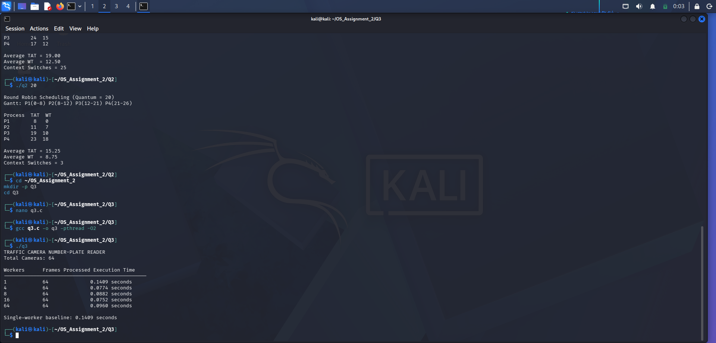
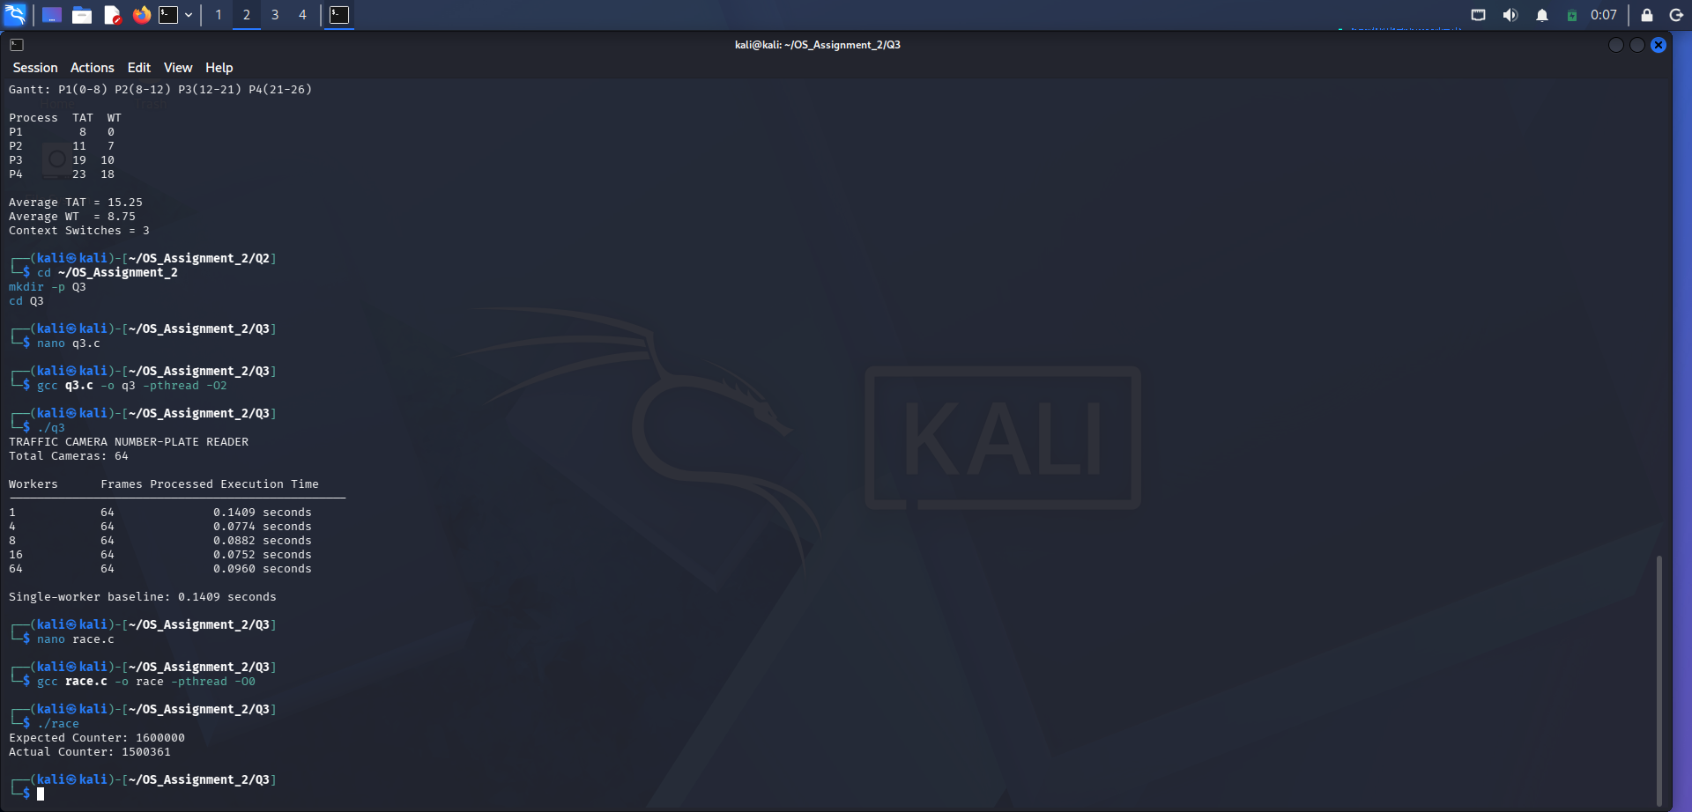

6. Speed-Up Analysis
Speed-up is calculated using:
Speed-up = Single Worker Time / Multiple Worker Time
The approximate measured speed-ups are:
Workers | Speed-up
1 | 1.00×
4 | 1.82×
8 | 1.60×
16 | 1.87×
64 | 1.47×
The 16-worker configuration provided the highest measured speed-up in this experiment.
However, increasing the number of threads does not always improve performance because thread creation, scheduling and synchronization also introduce overhead.

7. Alternative Concept and Complexity Analysis
If separate processes are used instead of threads, each process has its own virtual address space.
This provides better isolation but requires additional memory and inter-process communication.
Threads share memory, making communication easier. However, shared data must be protected using synchronization mechanisms.
The experiment demonstrates that the optimal thread count depends on CPU resources, workload size and synchronization overhead.
For a camera system, a fixed worker pool is preferable to creating a new thread for every frame.

8. Conclusion
The experiment successfully demonstrated multithreading using POSIX threads.
All 64 frames were processed using different worker configurations. The 16-worker configuration achieved the lowest measured execution time of 0.0752 seconds.
Therefore, an appropriate number of worker threads can improve the performance of a traffic camera monitoring system.

